React Native

**-Node.Js (**[**Download**](https://nodejs.org/en/download/)**)**

Versão: < npm –version >

**-Expo**

<https://expo.io/@helio_franca>  
Instalar: < npm install -g expo-cli> ou <npm install expo-cli –global>  
Versão: < expo –version >  
<expo login>  
<expo logout>  
<expo init “Nome do Projeto”  
<expo start>  
<npm start>

**-Python 2 (**[**Download**](https://www.python.org/downloads/release/python-272/)**)**

**-JDK 8 (**[**Download**](https://www.oracle.com/technetwork/java/javase/downloads/jdk8-downloads-2133151.html)**)**

**-React Native CLI**  
<npm install react-native-cli –global>  
<react-native --version>

**-Android Studio (**[**Download**](https://developer.android.com/studio)**)**

Download + Última Versão do Android.



<adb devices>

- Variáveis de ambiente

Em Variáveis de sistemas:  
ANDROID_HOME: C:\Users\LocalAdm\AppData\Local\Android\Sdk

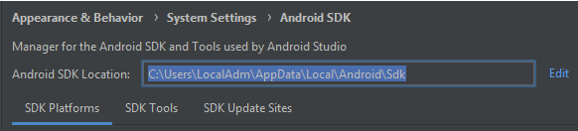

Testar: Echo %ANDROID_HOME%  
PATH: C:\Users\LocalAdm\AppData\Local\Android\Sdk\platform-tools

**-React Native**   
<react-native init “Projeto”>

Define versão do React Native:  
<react-native init “Projeto” –version 0.58.0>

<react-native run-android>